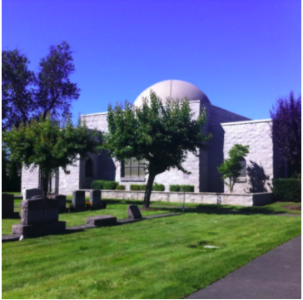
Selected Laws Concerning Observance of Yahrzeit
- Yahrzeit is observed on the yearly anniversary of the date of death on the Hebrew calendar.
- The Kaddish should be recited at evening, morning, and afternoon services on the day of the Yahrzeit.
- It is customary to give tzedakah (charity) on the Yahrzeit in memory of the deceased.
A candle should be lit for the duration of the Yahrzeit, and should be allowed to go out by itself. If the Yahrzeit is on Shabbos or Yom Tov, the candle must be lit before sundown. If the Yahrzeit is on the second day of Yom Tov, the candle may be kindled after nightfall only if enough light is produced so that some benefit is derived.
- If a Yahrzeit falls on a day when the Torah is read (Shabbos, Monday, Thursday, or holiday), a son should receive an Aliya. He should also receive an Aliya on the Shabbos immediately preceding the Yahrzeit.
- One should visit the gravesite on the Yahrzeit, except if it fall on Shabbos, Yom Tov, or some other joyous day, in which case one should do so on the day before the Yahrzeit. One is not obligated to incur a great expense in order to visit the gravesite.
- At the gravesite, one should recite selections from Psalms, the Kel Molei Rachamim, and if a Minyan is present, also the Kaddish.

